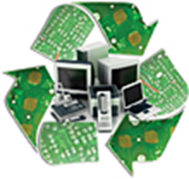
E-WASTE RECYCLING & COMPUTER REFURBISHING
www.calpia.ca.gov
*This form MUST be attached VISIBLY to EACH pallet or our driver will NOT transport. All e-waste pickups/drop-offs MUST be scheduled with the CALPIA E-Waste program.
Agency/Organization*:
Contact Name*:
Contact Phone #*:
Email*:
Pickup/Drop-Off Address*:
City, State, Zip Code*:
Alt. Contact:
Alt. Phone #:
Alt. Email:
Pallet #*: (example: 1 of 10)

CALPIA E-Waste Hotline: 916-229-3096 or ewaste@calpia.ca.gov
